APPENDIX E

MANAGEMENT OF THE DEMERSAL FISHERIES AT FAROE

Background
Faroe introduced vessel licensing in 1987, then TACs in 1994, followed in 1996 by effort management (individual transferable days at sea). TAC management was rejected because it caused discarding and high grading. There are some technical measures, including seasonal spawning area closures, and real-time closures for small fish.

Points made
Since introducing effort management at Faroe in 1996, fisheries managers have not followed ICES advice, which has recommended cuts in effort even when stocks are above B_{pa}. It is claimed that the Faroe effort system is successful because it allows fishermen to follow the natural fluctuations in stocks, and because landings of demersal fish have since increased.

Comment regarding the ICES advice
ICES recommends cuts in effort at Faroe (Table 1) because under the precautionary approach the advice is given in relation to both biomass and fishing mortality reference points (introduced in 1998, and modified in 1999). Even when Faroe stocks are above B_{pa}, ICES will advise effort reduction if F is above F_{pa} or F_{lim}. The exceptional ‘No fishing’ advice for haddock in 2002 followed a large downward revision in haddock SBB in the 2001 assessment, the year before stock increased due to increased recruitment.

Table 1. Recent ICES advice for Faroe gadoids.

Year Faroe cod Faroe haddock Faroe saithe
1999 F < F_{pa} F < F_{pa} F < F_{pa}
2000 F < F_{pa} F < F_{pa} F < F_{pa}
2001 F < F_{pa} F < F_{pa} Effort<< F_{pa}
2002 75% of F 2000 No fishing Effort < F_{pa}
2003 75% of F 2001 F < F_{pa} Effort < F_{pa}
2004 25% less effort F < F_{pa} Effort < F_{pa}

Comments regarding management success
Together with the technical measures, the allocation of fishing days by fleet at Faroe aims to achieve a fishing mortality of 0.45, equivalent to the removal of 33% of exploitable biomass annually. (ICES advice is more restrictive because it is based on Fpa values of 0.35 for cod, 0.25 for haddock, and 0.28 for saithe). Since 1996, Faroe has met the management target of F=0.45 for saithe, but not for cod and haddock. Table 2 shows that, since 1996, F for saithe was below 0.45 in most years, but this target has been achieved only twice for cod, and only four times for haddock, whilst for all three species F has never been below the ICES F_{pa} values. In fact, after effort management was introduced in 1996, the average fishing mortality for cod and actually increased, although it did decrease for saithe. From a fisheries science perspective, effort management at Faroe is therefore not meeting the cod and haddock management targets. Even so, fishing mortality on cod and haddock at Faroe is roughly half of the values observed in the principal cod and haddock stocks round the UK in the last decade, which means that, perhaps fortuitously, the Faroese stocks are less threatened than those around the UK.

Table 2.

Cod Haddock Saithe
Year F(ages 3-7) F(ages 3-7) F(ages 4-8)

Ave ‘87-93 0.25 0.22 0.48
Ave ‘94-95 0.48 0.24 0.50
Ave ‘96-00 0.57 0.44 0.33

1996 0.69 0.33 0.36
1997 0.73 0.39 0.31
1998 0.54 0.57 0.29
1999 0.53 0.56 0.34
2000 0.36 0.37 0.38
2001 0.45 0.40 0.48
2002 0.85 0.45 0.38

F_{pa} 0.35 0.26 0.28

Stock fluctuations
Cod and haddock landings at Faroe show strong cycles that have been observed as far back as 1903 (Gaard et al (2002). The current ACFM summary sheets show that since 1961 there are 5 clear cycles in cod landings (Figure 1), always preceded by a peak in the recruitment of two year old cod, and usually accompanied by a corresponding cycle in fishing mortality (Table 3). In Gaard et al. (2002), their Figure 8.14 shows that peaks and troughs in the recruitment, growth rate and yield of cod and haddock are all synchronised with trends in primary production. Gaard et al suggest that the troughs occur in years when phytoplankton on the Faroe shelf are overgrazed by intrusions of over-wintering oceanic copepods (Calanus finmarchicus).

For haddock there are similar peaks of two year old recruitment (1961-1963, 1968, 1974-1976, 1984-85, 1995, and 2001), and several corresponding peaks in landings (Figure 2), but fishing mortality does not follow this pattern, being low from 1975 to 1995, then doubling after 1996. For saithe (Figure 3) the pulses of recruitment and landings are less frequent (1969-71, 1981-83-86-88, 1999-01) and fishing mortality does not follow these pulses, but increased steadily from 0.1 in 1961 to 0.7 in 1991, before falling to 0.3-0.5 after 1996.

Table 3.

Peak Landings | Peak Recruitment | Peak Fishing Mortality
1968-69 | 1966-68 | N/A
1975-77 | 1974-75 | 1977
1983-86 | 1984 | 1983, 85,86
1996-97 | 1994-95 | 1996-67
2001-02 | 2001 | 2002

Reference
Gaard, E., B. Hansen, B. Olsen, and J. Reinert (2002). Ecological Features and Recent Trends in the Physical Environment, Plankton, Fish Stocks, and Seabirds in the Faroe Shelf Ecosystem. Pages 245-265 in K. Sherman and H.R. Skoldal (Editors), Large Marine Ecosystems of the North Atlantic, Elsevier Science BV.

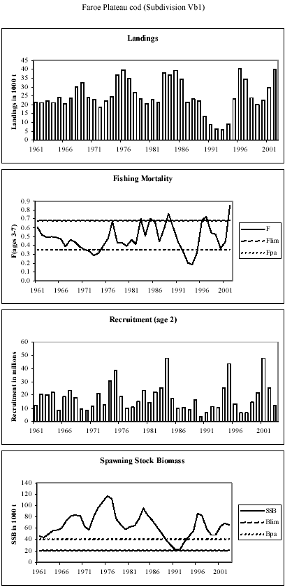

Figure 1 (from ACFM May 2003).
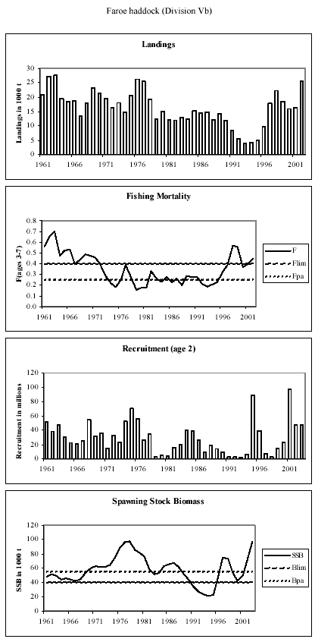

Figure 2 (from ACFM May 2003).
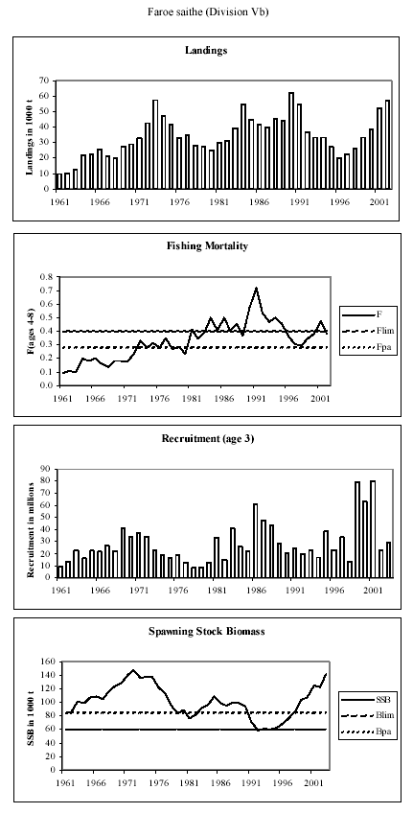

Figure 3 (from ACFM May 2003).

